**Exercise 6: Library Management System**

**Scenario:**

You are developing a library management system where users can search for books by title or author.

**Steps:**

1. **Understand Search Algorithms:**
   * Explain linear search and binary search algorithms.
2. **Setup:**
   * Create a class **Book** with attributes like **bookId**, **title**, and **author**.
3. **Implementation:**
   * Implement linear search to find books by title.
   * Implement binary search to find books by title (assuming the list is sorted).
4. **Analysis:**
   * Compare the time complexity of linear and binary search.
   * Discuss when to use each algorithm based on the data set size and order.

**CODE:**

using System;

class Book

{

public int BookId { get; set; }

public string Title { get; set; }

public string Author { get; set; }

public Book(int id, string title, string author)

{

BookId = id;

Title = title;

Author = author;

}

}

class LibrarySearch

{

public static Book LinearSearch(Book[] books, string title)

{

foreach (var book in books)

if (book.Title == title)

return book;

return null;

}

public static Book BinarySearch(Book[] books, string title)

{

int left = 0, right = books.Length - 1;

while (left <= right)

{

int mid = (left + right) / 2;

int comp = string.Compare(books[mid].Title, title);

if (comp == 0) return books[mid];

else if (comp < 0) left = mid + 1;

else right = mid - 1;

}

return null;

}

}

class Program6

{

static void Main()

{

Book[] books = {

new Book(1, "C Programming", "Dennis Ritchie"),

new Book(2, "Java Basics", "James Gosling"),

new Book(3, "Python Guide", "Guido van Rossum")

};

Array.Sort(books, (a, b) => a.Title.CompareTo(b.Title));

Console.WriteLine("Linear Search: " + LibrarySearch.LinearSearch(books, "Java Basics")?.Author);

Console.WriteLine("Binary Search: " + LibrarySearch.BinarySearch(books, "Java Basics")?.Author);

}

}

**OUTPUT:**

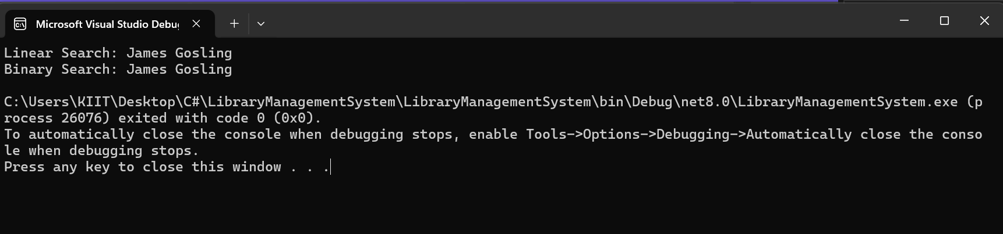

**ANALYSIS:**

**Linear vs Binary Search:**

* **Linear:** No sort needed, O(n)
* **Binary:** Needs sorted array, O(log n)

**When to use each:**  
**Linear should be used** for small/unsorted data while **Binary** for large/sorted datasets.